**CS4560 Assignment 4. Initial project setup**

**(Team Assignment. Due on Thursday, Week 4.)**

**Submission: Check in the documents to your team Git repository. Send an email message to the TA and copy the instructor describing which files (with links) are for this submission. Copy all team members on this message. The subject of the message should be “Fall 2016 CS4560 HW4 Team XXX Submission”.**

**Note that some items must be completed earlier so that this assignment can be completed on time.**

* Add a profile picture on Github if you haven’t done so already.
  + Done
* Create GUI Mockups that help explain the use cases and scenarios that you created in the previous homework assignment. Revise those use cases and scenarios if necessary. Ask for client feedback if possible.
  + Seattle will draw
* Describe the proposed architecture of the project in both diagrams and textual descriptions

Our technology stack involves the use of Android SDK using Java, and Python.

The two main languages we think we will be using in this project are Java and Python. We will be using these languages in the following ways:

**Java**

* OpenCV, unless it is proven to be too lacking in functionality
* AndroidSDK, the front end of the app will be built here, and the functions of the cat will be implemented here as well

**Python**

* Will be used to improve upon existing functionality, as more efficient algorithms exist to solve the problems we are facing in this language versus what is available in OpenCV
* NLP and Face Recognition can be implemented efficiently in Python.

The diagram below shows this architecture.

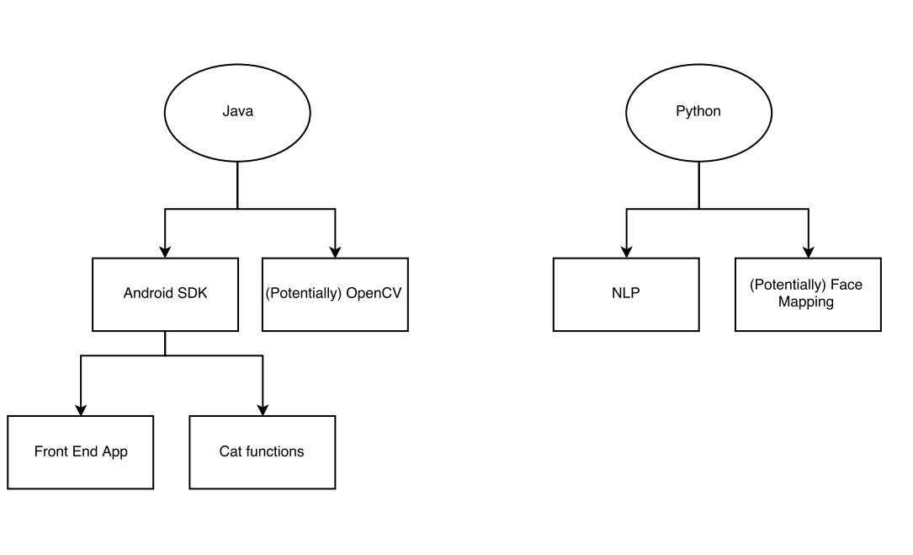

* For the technology stack that you plan to use, create Hello World demos.
  + 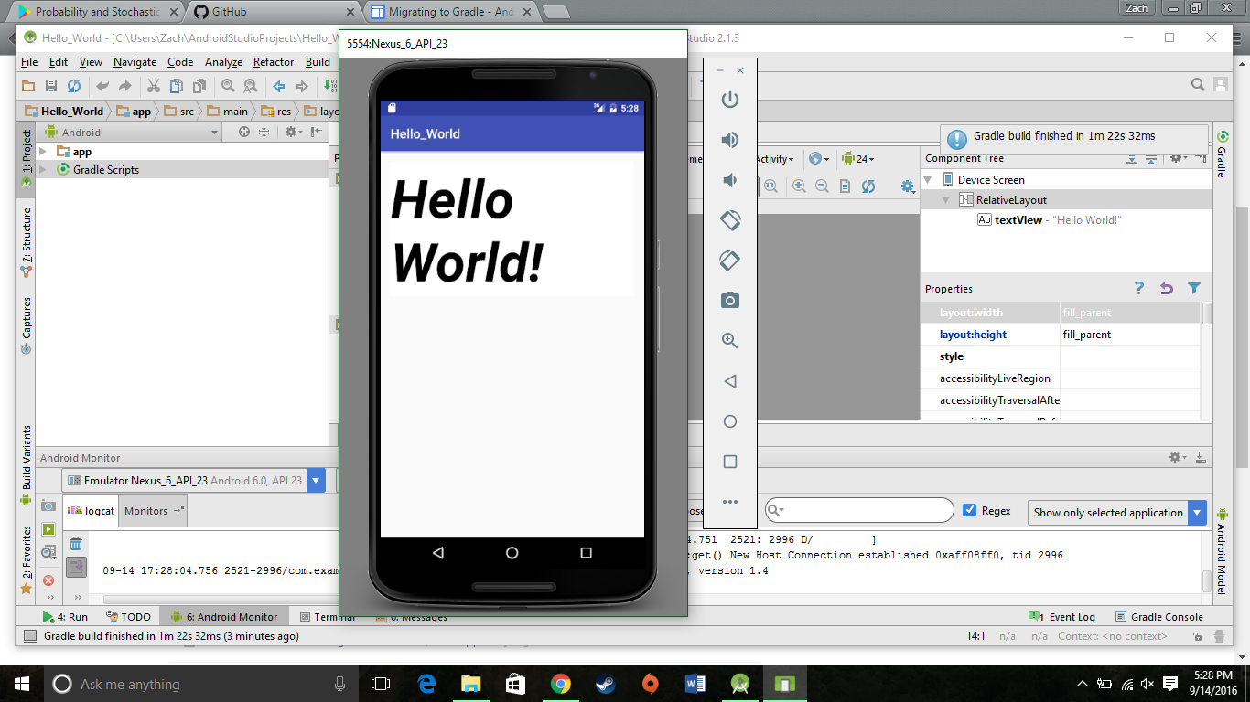

Android Studio Hello World app running on a Nexus 6 emulator

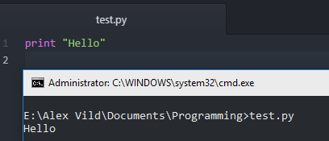

A hello world progam written in Python

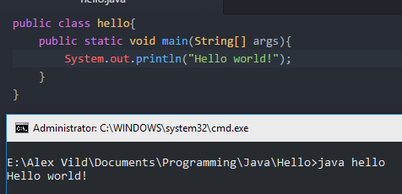

A hello world program written in Java

* Write a description of four milestones to reach or go beyond MVP (Minimum Viable Product). Each milestone should last about two weeks.

The six of us will break into three specialized groups of 2 to tackle the problems proposed to us; collaboration by the entire group on these problems will occur twice weekly at our group meetings.

* + **Receive and Execute voice commands by the user:** 
    - **Milestone 1:** Get familiar with NLP algorithms and the functionality that is implemented in the cat currently. Remove the need of a button press to begin listening, instead the cat should start listening when a trigger word is said.
    - **Milestone 2:** Add at least one new additional command to the cat's library, “speak” that makes the cat meow. Begin implementing technology to detect emotion and loud surprising noises. Also Make the cat be able to listen to voice commands continuously as opposed to having to push a button every time we want to issue a command.
    - **Milestone 3:** Begin refining emotion/noise detection
    - **Milestone 4:** Fully implement emotion detection/noise detection
  + **Facial Recognition:**
    - **Milestone 1:** The overall accuracy of facial recognition will be improved.
    - **Milestone 2:** Upon detecting a face, the cat will more accurately move its head to center the image of a face in it’s field of view.
    - **Milestone 3:** Upon detecting multiple faces, that cat will periodically shift its attention between the faces. The cat will also be able to search for and track, via head movements, objects of any user specified color in the environment; this color can be specified by voice command or by a button in the GUI.
    - **Milestone 4:** Basic emotion detection based upon the facial expression in a detected face will be implemented. At the least, this will include detection of anger and happiness.
  + **Environmental Mapping:** 
    - **Milestone 1:** Decide on which new hardware component to introduce for environment mapping. We are looking for something that connects the Android phone to the Arduino board and to the servo controller simultaneously. Currently, the phone only communicates with the servo controller.
    - **Milestone 2:** Establish communication between the Arduino board, the new hardware, the servo controller, and the app. Determine the way that we want the environment map to be displayed for testing purposes.
    - **Milestone 3:** Display the environment map as observed by RoboCat. He should have the ability to look around and “see” his surroundings.
    - **Milestone 4:** The final goal for environmental mapping is for RoboCat to be able to navigate autonomously in an unknown environment. We want the code in place that allows this functionality (whether he is able to walk yet or not based on limitations).
  + **Log Accelerometer data**: record data from accelerometer and store in a file.
  + **Battery indicator:** light on cat indicates battery status.
  + **Battery Indicator:** Cat will have altered behavior when battery is low.